 |  | Mohammad hadi Hosseini
 |  | Digital marketing manager
 | Email :hadihosseininet@gmail.com | Mobile :+989379439934
 | Phone : _ | City :Iran,Shiraz
 | Marital Status : Single | DoB :July19,1998
 | Military Service Status :covered | Website : hhoseini.ir
about
Digital marketing expert and professional and specialized activities in website design, development of internet and online businesses, advertising, photography, editing, graphic design, SEO and optimization and management of social networks and site news. Marketing with proven experience in planning and coordinating marketing programs such as determining the demand for products and services offered by a firm and it’s competitors in order to identify new potential customers.
Work Experiences

- Website designer and business consultant

- www.dgdena.ir  - www.Blackgarlic.ir  - www.Farsiha.ir  - www.Bornakombucha.com  - www.Daybo.ir  - www.ir-media.ir  - www.Khomi-news.ir  - www.pedramvip.com | 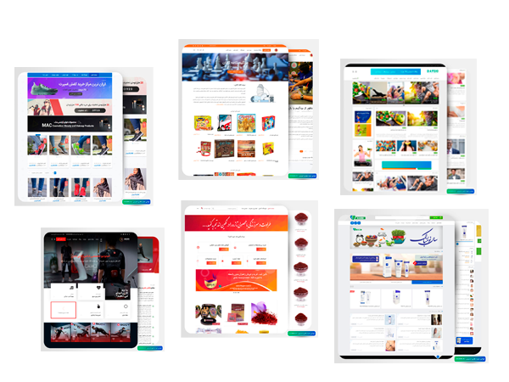

Skills
☑ Filming, edit videos and make teasers | ☑ SEO and web browser optimization | ☑ Web designer
☑ Ideation and creativity | ☑ CMS | ☑ Internet marketing
☑ HTML/CSS | ☑ Photography | ☑ Adobe Photoshop
☑ Google web master  ☑ Design and implement an online advertising campaign  ☑ Motion graphic | ☑ Advertising and branding on social media  ☑ XAmpp  ☑ Camera raw | ☑ Photoshop graphic design  ☑ power point& word office  ☑ Adobe premiere Pro  ☑ Content development and engineering for businesses
Languages
Title | Reading level | Writing level | Speaking level | Listening level
English | ★★★ | ★★ | ★★ | ★★
Persian | ★★★★★ | ★★★★★ | ★★★★★ | ★★★★★
Achievements
- The best art and advertising managment
Date :2020
- Statue of the most successful artistic figure of the year ,Kohgiloyeh va boyerahmad
Date : 2019

